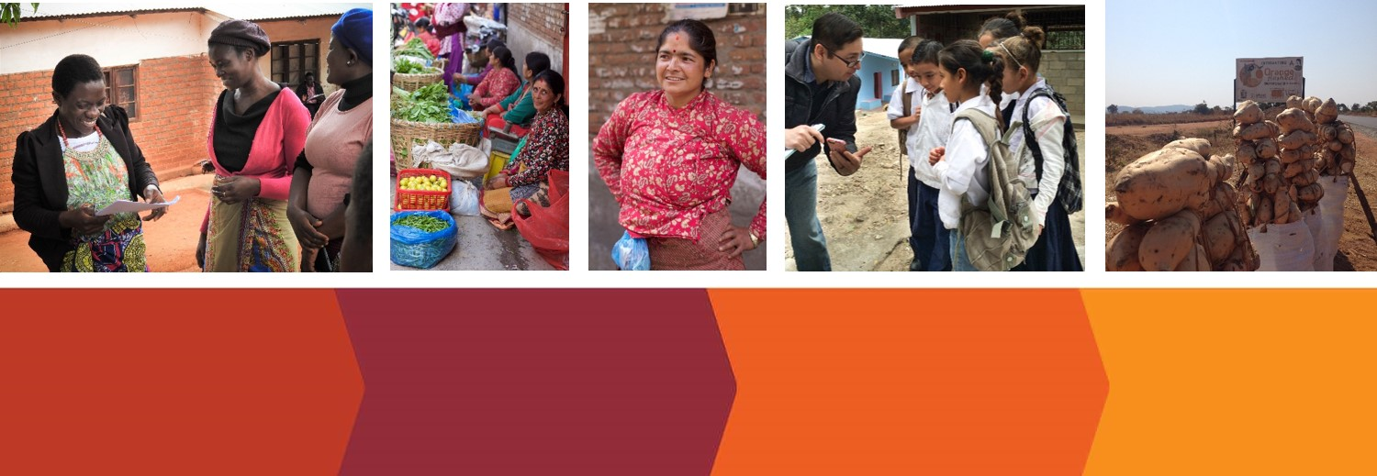
Revalorizing Extension: Evidence and Practice
Call for Proposals
for the Spring Symposium at the University of Illinois at Urbana-Champaign from April 2-3, 2018

Proposal submitted by: Proposal to:
First Name: |  |  |  | present a research based seminar (15 min)
Last Name: |  |  |  | display a research based poster
Job Title: |  |  |  | speak on a panel
Organization: |  |  |  | share material (e.g., job aides; training material, devices)
Country:
Email Address:

Are you registered for the event? ___ (if NO: Please first register at https://spring18symposium.eventbrite.com)

Please indicate which topic(s) the presentation or poster pertains to
Effective extension methods at the farmer, organizational, and country/system levels
Innovative approaches to sustainably reach women farmers and youth
Using ICTs to empower staff and reach more farmers
The political economy of agricultural extension
Extension in post-conflict and post-disaster contexts
Partnerships to strengthen extension
Extension for improved nutrition, natural resource management, and sustainable agriculture
Extension for postharvest loss prevention
Market oriented advisory services, including advice on meeting food safety standards
Other

Which of these questions will your contribution help address?
How to highlight extension’s crucial role in international agricultural development
What works in agricultural/rural advisory services and why
How to effectively deliver extension services to smallholder farmers
What it takes to increase support for extension services
Short Description
In the space below, please write an abstract/short description not more than 750 words of what you plan to contribute. Include: (a) Introduction (b) Purpose of the paper/poster (c) Methods or data sources (or reasoning used in theoretical/philosophical papers), (d) Results, (e) Conclusions and extension implications.

Where was the research conducted?
During which time period?
How was the research funded?

Selection Criteria
Submissions will be reviewed upon the strength of contribution to the symposium theme(s), importance of the research question, quality of analysis, contribution to extension evidence base, and contribution to practice and policy. Please write clearly and follow the outline.
Cost of attendance and limited funding support
There is no fee to attend and present at the symposium. Some meals will be provided, but all participants are responsible for covering all their own travel related expenses. Some funding is available to help offset travel expenses for a limited number of graduate students, who will be selected based on the merit of their proposal.
Timeline
November 6, 2017: Call for proposal is issued
January 15, 2017: Proposals are due
January 16-31, 2018: Committee reviews proposals and makes recommendations for acceptance/ denial
February 7, 2018: Notice of acceptance, wait-list or denial are sent out
Submission
Please submit the completed form via email to Andrea Bohn at abohn@illinois.edu by January 15, 2018.

