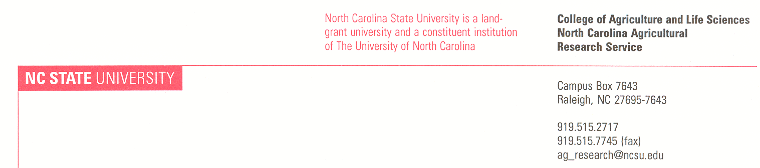

Dear Dr. Smith,

This is a reminder that you must file a progress report on Year 1 of your Dean’s Enrichment Grant no later than June 1, 2015. The Year 2 project period is July 1, 2015 through June 30, 2016. Funding for year one is $xxxxx and for year two is $xxxxx for a total of $xxxxx. If your understanding of funding distribution is different, please contact our office. Because these are state funds, **Year 1** **funding must be expended by June 30, 2015 (no carry forward allowed)** so please watch for encumberance deadlines which will fall earlier.

The progress report will be used to determine the release of Year 2 funding based on progress in Year 1. When completing your report, please keep in mind the over-arching priorities of this program as described in the RFP including: establishment of new multi-disciplinary collaborations, integration of missions/strategic themes across institutions, development of innovative/novel projects, increasing opportunities for external funding, and integration of the land grant mission (research, teaching and Extension).

You may submit your report on-line using the following link:

<http://go.ncsu.edu/cals-deans-enrichment-report>.

(Control + Click OR copy and paste into your browser)

If you prefer, you may complete the attached Word file of the report template and return it by email to [cals_research@ncsu.edu](mailto:cals_research@ncsu.edu).

Again, I want to thank you for participating in the Dean’s Enrichment program. I am excited to learn of your progress.

Thank you.

Sincerely,

S:\Administration\NCARS\OFFICE\SIGNATURES-Bios\David Monks small.tif

David Monks

Associate Director, NCARS