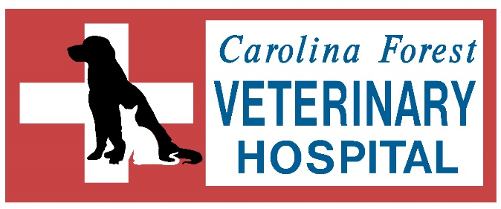

Veterinary Medicine Internship Program
Carolina Forest Veterinary Hospital would like to offer an internship opportunity to qualified pre-veterinary/veterinary medicine students. Internship availabilities are open to one student per spring, summer and fall semesters. The internship will offer an educational, hands-on experience in a small animal practice for aspiring veterinarians. All training will be under the direct supervision with either a veterinarian or licensed/senior veterinary technician. The educational opportunity for this internship includes, but is not limited to, the following:

- Observation of all areas of the hospital (reception, treatment, surgery and kennel)
- Familiarize themselves with the veterinary software
- Basic clerical work
- Prepare rooms for upcoming appointments
- Shadow the doctors in exam rooms
- Assist technicians with patients (check temps, retrieve fecal samples, and get weights)
- Gain knowledge of prescription diet foods and over the counter products
- Restock shelves
- Clean cages
- Assist kennel technicians with boarding and bathing of patients
- Gain knowledge in performing in-house tests
- Learn proper documentation of medical records

For more information on this internship program or to receive an application contact Jessica or Kim via email carolinaforestvh@yahoo.com.

Carolina Forest Veterinary Hospital
209 Ronnie Ct
Myrtle Beach, SC 29579
Phone: 843-236-7383
Fax: 843-236-9141
carolinaforestvh@yahoo.com

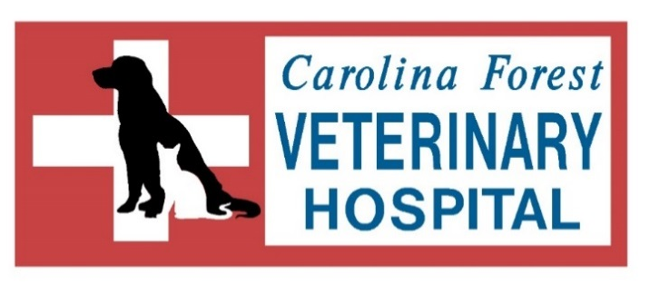
Internship Application
Student Name: _______________________________________________ Date: ______________________
Present Address: _________________________________________________________________________
Telephone Number: _________________________ Email: ________________________________________
School Name: ____________________________________________________________________________
Major: ____________________ Expected Graduation Date: _____________ Grade Level: ______________
Internship Term: ____ Fall _____ Spring _____ Summer Total Hours Needed: ______ Hours/wk: _____

Student Advisor Info:
Advisor Name: _____________________________ Telephone Number: _____________________________
Email:___________________________________________________________________________________
Emergency Contact:
Name: __________________________________________ Relation: ________________________________
Telephone Number: _____________________________________
What goals do you hope to achieve in this internship? ____________________________________________
_________________________________________________________________________________________
_________________________________________________________________________________________
_________________________________________________________________________________________
List any extracurricular activities/leadership roles: _______________________________________________
_________________________________________________________________________________________
_________________________________________________________________________________________

I certify that all of the above information on this application is true and complete to the best of my knowledge. I understand that any information found to be untrue or omitted may disqualify me from further consideration of the internship.
Student Signature _________________________________________ Date _____________________

